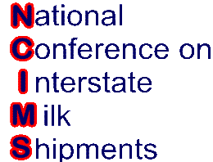
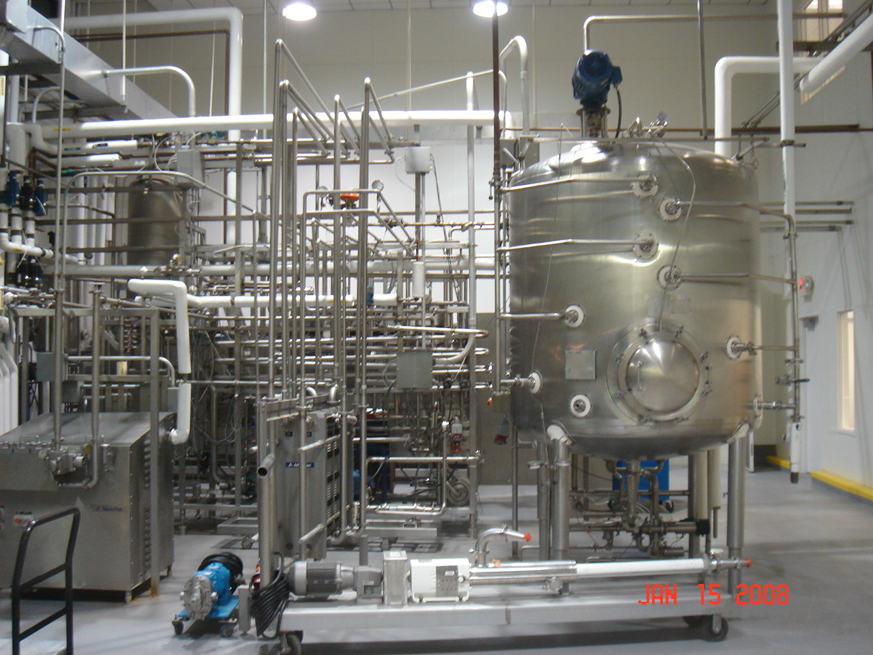
NCIMS Aseptic Pilot
Program Training
Webinar October 1 & 2, 2008
11:00 a.m. – 2:00 p.m. EDT

Registration Form

Name: ______________________________________________________________

Employer: ___________________________________________________________

Job Title: ___________________________________________________________

Mailing Address: ______________________________________________________

City: State: Zip: ____________

Tel # ( )__________________ Fax # (____)____________________

E-Mail Address: _____________________________________________

Registration Fee $50.00
Make Checks payable to: NCIMS
NATIONAL CONFERENCE on INTERSTATE MILK SHIPMENTS

Return check & Registration Form to:
Mr. Brian Fields
International Dairy Foods Association
1250 H St. NW, Suite 900
Washington, DC 20005
(202)-220-3566
(202)-331-7820 FAX
bfields@idfa.org EMAIL

Please see the NCIMS Aseptic Pilot Program Webinar agenda below. Further details and materials will be e-mailed to you prior to the webinar.

NCIMS Aseptic Pilot Program Webinar Agenda

Please note: the times of day listed below are Eastern Time.

First Day, October 1

11:00 am Introduction to Webinar Format, Theresa Gandolph

11:05 am Welcome and Background on NCIMS Proposal 303, Overview of Aseptic Pilot Program, Susan Esser

11:45 pm Role of the Process Authority, Brian Thane

12:15 pm Break

12:30 pm Role of FDA LACF, Dan Geffin

1:20 pm Responsibilities of Industry, Roger Hooi

1:35 pm Responsibilities of FDA Regional Milk Specialist, Robert Hennes

2:05 pm End of First Day's Webinar

Second Day, October 2

11:00 am Welcome, Susan Esser

11:10 am Committee Addresses Q & As from First Day, Lew Turner

11:30 am Responsibilities of State Regulatory and State Rating Officials including PMO, Methods, Procedures and Forms, Kathy Stodola

12:30 pm Break

12:45 pm Mock Exercises, Perry Verner

1:45 pm Examination Instructions, Susan Esser

2:00 pm End of Second Day's Webinar

