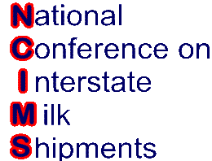 (Rev.2/2023)

NCIMS Hall of Fame Nomination Form

Name of Candidate, Most Recent Title & Organization: _____ ______ ___

__________________________________________________________________ ___________

Candidate Contact Information: _________________________________________ ________

Affiliation or Dairy Sector(s) Represented by Candidate:

Processing ____ Producer ____ State Regulatory/Rating _____ FDA______ Other: __ ___

Short Justification for nomination:

Short Biography of the Candidate describing dairy related experience, including a list of responsibilities, accomplishments and awards (attach):

Specific Contributions to the NCIMS may include but are not limited to:
- Number, dates & locations of NCIMS Conferences registered and attended
- Number of NCIMS Proposals submitted, including Conference year of submission
- NCIMS Volunteer activities

NCIMS Board, Council, Committee, Delegate or Advisor Activities (list individually with explanation. Attach page(s) as needed):

Submitter Contact Information:

Submitter Name: Affiliation:

E-mail: Phone:
Submit no later than February 21, 2023 by e-mail to:
Cary Frye, Executive Secretary, National Conference on Interstate Milk Shipments
ncims.frye@outlook.com

